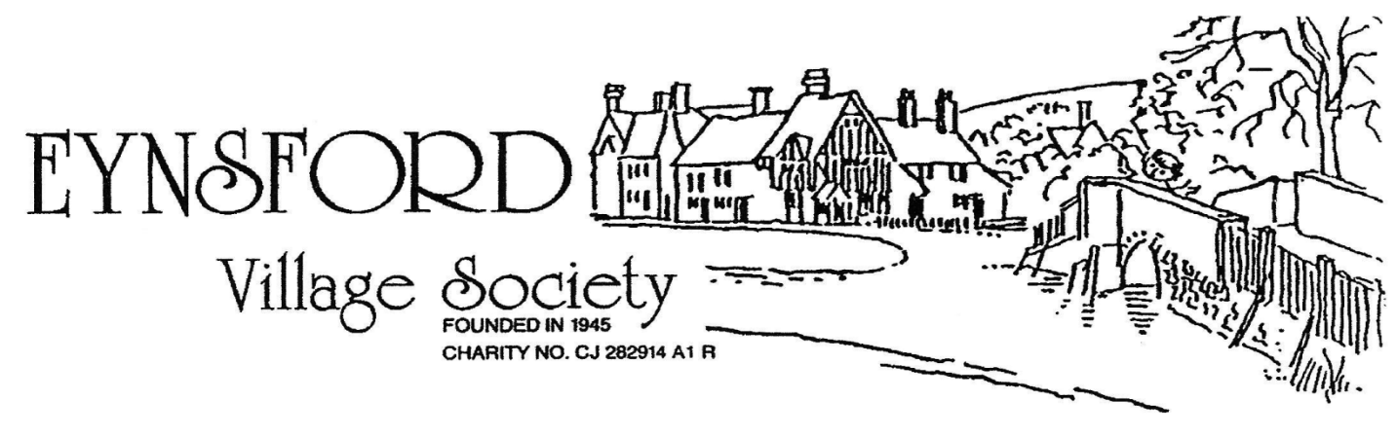

WE NEED YOU!
For 80 years, Eynsford Village Society (EVS) has helped protect the character of our village and strengthen its community spirit – from supporting Eynsford in Bloom (EIB) and helping secure Millfield, to welcoming new residents, arranging and running village events and celebrating our shared history.

The Society now needs energy and new officers to carry this work forward. If you can offer time, ideas, or skills, please consider joining us at the AGM on Friday 01 May which will be held at Farningham Village Hall at 6.30pm.

To express interest or share suggestions contact our Secretary, Sally Pennington, at sally linc@hotmail.com . Help shape the next chapter of Eynsford’s story.

